Task 1:
End-to-End WAN Connection Path (Home Wi-Fi to Instagram Server)

Objective: Map and document the end-to-end network architecture tracing packet traversal from a mobile client across local wireless, ISP gateway infrastructures, and intermediate WAN routing nodes to Instagram's cloud edge servers.

1. Text-Based Network WAN Traversal Diagram

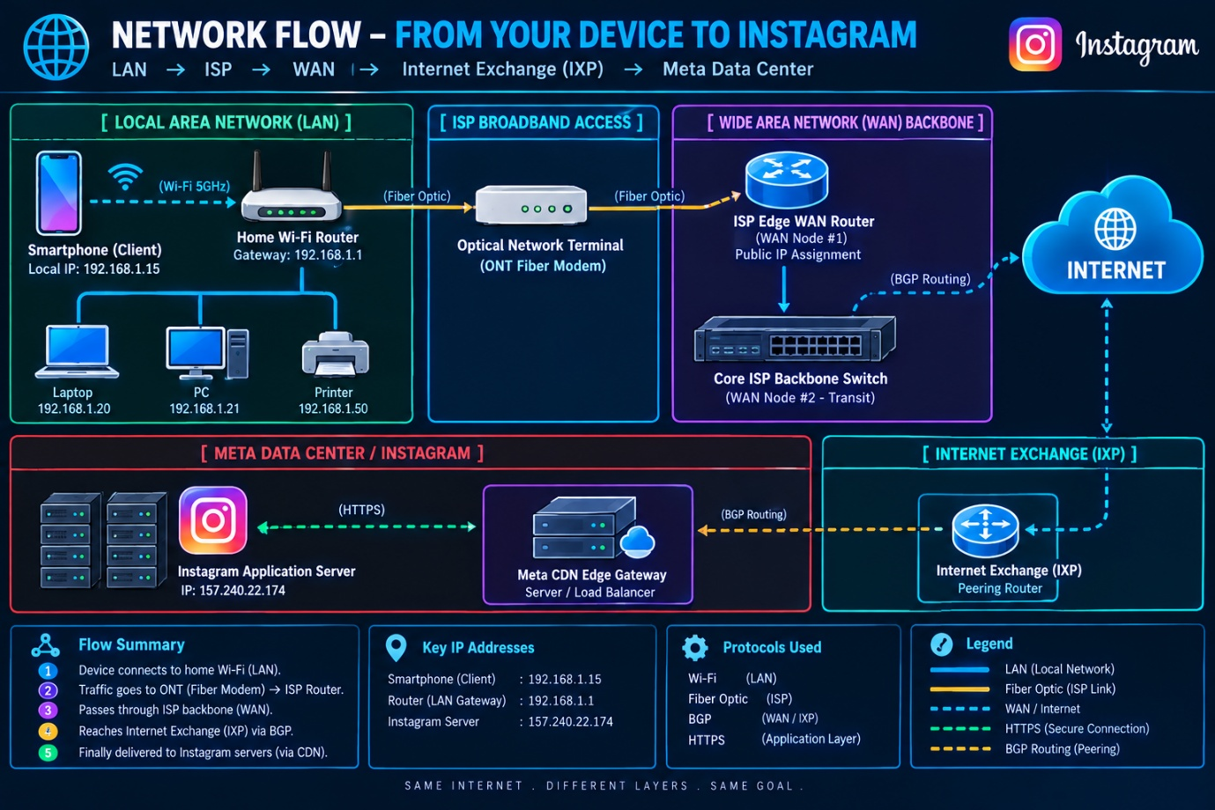

2. Network Hop Breakdown & Device Functionality:
1.Smartphone & Home Wi-Fi Gateway (LAN Level):Node 1.
The smartphone generates an HTTP/HTTPS API request and transmits it over 5 GHz Wi-Fi radio waves to the Home Router (Cisco/TP-Link). The router performs Network Address Translation (NAT) to convert private IP 192.168.1.15 into a public IP.
2.Optical Network Terminal (ONT / Modem):Node 2.
The home router passes data packets to the ONT modem via an Ethernet RJ45 cable, converting digital electrical pulses into modulated optical light signals sent over Fiber-to-the-Home (FTTH) cable.
3.ISP Edge WAN Router (Local Exchange / POP):WAN Node #1.
The fiber cable connects to the Internet Service Provider's (Airtel/Jio) local Point of Presence (POP). The ISP Edge Router authenticates the PPPoE connection, assigns public IP routing, and forwards packets into the provider network.
4.Core ISP Backbone Router / Switch:WAN Node #2.
High-capacity fiber switches in the ISP's core backbone inspect packet destination headers, utilizing Border Gateway Protocol (BGP) to select the fastest fiber route across state and national lines.
5.Internet Exchange Point (IXP) & Meta Server:Node 5.
Traffic enters an Internet Exchange Point (IXP) where the ISP peers directly with Meta’s Content Delivery Network (CDN). The request reaches Instagram’s Load Balancer / Edge Gateway Server, which returns requested feed data back along the same path.

Task 2:
WAN Technologies Comparison Matrix (Broadband vs Leased Line vs MPLS)

Objective: Compare 3 mainstream Wide Area Network (WAN) technologies across critical performance metrics (Speed, Cost, Reliability/SLA) and map their practical real-world application deployments.

1. WAN Technologies Comparison Table:

Comparison Parameter | Broadband Internet (FTTH / Cable) | Dedicated Leased Line | MPLS (Multiprotocol Label Switching)
Technology Description | Shared public internet connection delivered via Fiber-to-the-Home (FTTH), DSL, or coaxial cable. | Dedicated 1:1 unshared point-to-point fiber connection connecting two fixed business locations. | Private packet-switched WAN mesh network using labels for high-speed routing and Traffic Prioritization (QoS).
Speed & Bandwidth | High Download speeds (100 Mbps – 1 Gbps), but Asymmetric (Slower upload speeds). | High Symmetric speeds (10 Mbps – 10 Gbps) with guaranteed bandwidth. | Customizable Symmetric speeds (2 Mbps – 10 Gbps) per branch site.
Cost Structure | Low Cost (₹500 – ₹1,500 / month). Best price-to-bandwidth ratio. | Very High Cost (₹50,000 – ₹2,00,000+ / year). Charged per dedicated point-to-point distance. | High / Enterprise Cost (Based on number of connected sites and SLA guarantees).
Reliability & SLA | Low to Moderate (Shared medium, no strict SLA uptime guarantee). | Maximum Reliability (Guaranteed 99.9% uptime Service Level Agreement). | Extremely High (Guaranteed Quality of Service - QoS for real-time voice & video data).
Real-Life Deployment Example | Your Home / Local Cyber Café: Used for daily web browsing, streaming YouTube/Spotify, and online gaming. | IRCTC Railway Ticket Counter / HDFC Bank ATM Network: High-security, ultra-low latency real-time transactional connection to central servers. | Zomato / Flipkart Corporate Offices & Multi-State Warehouses: Connecting regional hub offices across India to central ERP/database cloud seamlessly.

Task 3:
Secure WAN Access via Virtual Private Network (VPN) Tunneling

Objective: Explain how a Virtual Private Network (VPN) establishes an encrypted virtual tunnel across unencrypted public Wide Area Networks (WANs) to secure user traffic against packet sniffing on untrusted public Wi-Fi networks.

1. Core Concept: Private Tunneling Over Public WAN:
When connecting to an open public Wi-Fi network at a coffee shop, local network traffic is unencrypted and vulnerable to Man-in-the-Middle (MitM) attacks and packet sniffing.
A Virtual Private Network (VPN) solves this by establishing a secure, end-to-end Encrypted Virtual Tunnel across the untrusted public WAN infrastructure using security protocols such as WireGuard, OpenVPN, or IPsec.

[ Smartphone (Coffee Shop) ] ===( Encrypted VPN Tunnel )===> [ Public WAN / ISP ] ===> [ Remote VPN Server ] ===> [ Spotify / YouTube ]
2. Step-by-Step Data Flow Execution:
1.Packet Encryption at Source Device:Step 1.
When you open Spotify or YouTube, the VPN client software installed on your device intercept the outgoing network packets and encrypts the payload using strong cryptographic algorithms (e.g., AES-256 bit encryption).
2.Transmission Through Encrypted Tunnel:Step 2.
The encrypted payload is wrapped inside a standard network packet (Encapsulation) and sent across the coffee shop's local Wi-Fi router and public WAN. Anyone sniffing network traffic at the coffee shop only sees scrambled, unreadable binary data.
3.Decryption at Remote VPN Gateway:Step 3.
The encrypted stream traverses the public WAN and terminates at the remote VPN Provider's Server. The VPN server decrypts the traffic payload and assigns its own public IP address.
4.Forwarding to Target Application Servers:Step 4.
The VPN server forwards the clean, decrypted request to Spotify's or YouTube's content servers. The target app processes the request and sends data back through the same encrypted tunnel to your device.

3. Key Security Benefits:
- Data Confidentiality: Prevents malicious attackers on the same public Wi-Fi network from viewing passwords, cookies, or video streams.
- IP Masking & Anonymity: Hides your real geographical IP address from target web servers, replacing it with the VPN server's virtual IP address.

Task 4:
Enterprise WAN Solution for Flipkart Warehouses (Ahmedabad, Mumbai & Delhi)

Objective: Recommend and justify the optimal Wide Area Network (WAN) technology architecture to connect Flipkart's high-throughput fulfillment centers located across Ahmedabad, Mumbai, and Delhi.

1. Recommended WAN Technology:
Recommended Technology: MPLS (Multiprotocol Label Switching) / SD-WAN (Software-Defined WAN)
For connecting core logistics hubs across major metro cities, an MPLS-based Private Network (or SD-WAN configured over MPLS) is the ideal solution for enterprise-grade performance, reliability, and security.

2. Justification with 2 Primary Business Reasons:
Reason 1: Guaranteed Low Latency & Quality of Service (QoS) for Real-Time Inventory Sync
- Justification: Flipkart warehouses process thousands of automated order dispatches, barcode scans, and real-time database syncs per minute between Ahmedabad, Mumbai, and Delhi.
- Impact: Unlike standard public broadband internet, MPLS assigns explicit traffic labels that prioritize critical data (ERP systems, Inventory Databases, and Warehouse Management System API calls) with guaranteed low latency and zero packet loss.
Reason 2: High Reliability with Enterprise Service Level Agreements (SLAs) & High Security
- Justification: Private MPLS creates an isolated, private network mesh that is completely separated from the public internet, preventing cyber threats and packet interception.
- Impact: Telecom providers deliver strict 99.9% Uptime SLAs on MPLS circuits. In the event of a fiber cut, dynamic rerouting immediately redirects traffic through backup links without halting warehouse sorting or shipping operations.

3. Network Architecture Summary:
Feature | Requirement for Flipkart Warehouses | MPLS / SD-WAN Solution Capability
Locations Connected | Ahmedabad, Mumbai, Delhi Warehouses | Private Any-to-Any Mesh Topology
Data Priority (QoS) | Real-time Inventory & ERP sync | High priority packet routing via label switching
Uptime Guarantee | 24/7 continuous warehouse operations | 99.9% Uptime SLA with dynamic link failover
Data Security | High protection for customer/order data | Fully isolated private WAN tunnel (Off-Internet)

